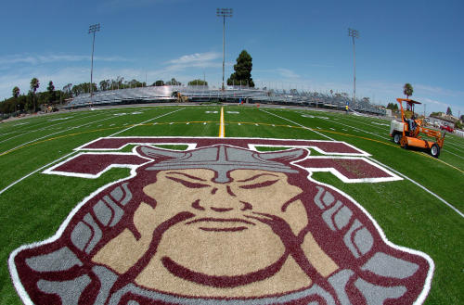z

February 22, 2025

Zamperini Stadium:

2320 Crenshaw Bl.

Torrance, CA 90501

Start Time: 8:30am – Running / Field

TEAM / ATHLETE COST:

$25 per event, $50 per relay, $200 per gender and $300 combined boys and girl’s teams

Entries:

1600m - Unlimited

Relays – 3 teams per relay / per level

Field Events:

S.P. / Disc. – 4 per school / per level

L.J. / T.J. – 4 per school / per level

H.J. / P.V. – 4 per school / per level

General Admission:

Adults - $10

Seniors - $5

H.S. Students - $5

Children under 12 - Free

www.thstf.com/zamperini

www.thstf.com/directions

Events and Order:

1600m

4x100

4x800

800 SMR - (1,1,2,4)

DMR

4x200

Pole Vault

Shot Put

Disc

L.J.

T.J.

H.J.

Awards:

Medals - Top 3 overall per event / per division

Entries:

Athletic.net

Deadline: 11:00PM

Wednesday, Feb. 19, 2025

Checks:

Made out to THS Track

Checks are due on Thursday, Feb. 20, 2025.

Mail: Kyle Irvine

THS Track and Field

2200 W. Carson St.

Torrance 90501

DIRECTIONS:

See Map Below

Contact:

Kyle Irvine

310-283-1878 - cell

Isa4522@startmail.com

# Louis Zamperini Invitational

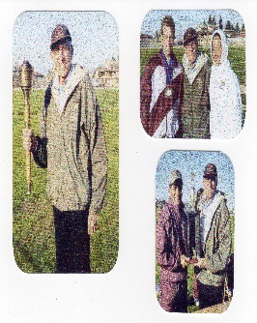

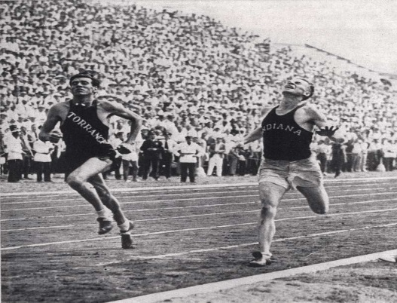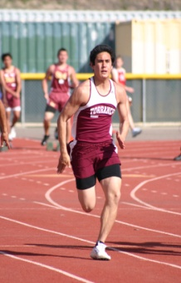

**Louis Zamperini Invitational**

**Levels**: Varsity & F/S - Boys & Girls

**Events**:

**1600m**

**4x100**

**4x800** – 4 races (one race per level) no heats

**800 SMR** (**1,1,2,4**)

**DMR** – Two races (combined girls / combined boys)

**4x200**

**Field Events**: PV, S.P., DISC, H.J., L.J., T.J.

**Medals**: Top 3 overall per event / per level

**Approximate:**

**Event #1** 1600m– Boys / Girls 8:30am **Event #20- Pole Vault – 8:30am**

**Event #2** 4x100 – F/S -Boys 10:00am **Opening Height** – 6” 0” – F/S – G

7’ 0” – V/G

**Event #3** 4x100 – F/S - Girls 10:10am 8’ 0” – F/S - B

10’ 0” – V/B

**Event #4** 4x100 – Varsity – Girls 10:20am

**Event #21 – High Jump – (Two Pits) 8:30am**

**Event #5** 4x100 – Varsity – Boys 10:30am

**Opening Heights** – 3’ 8” / 4’8”

**Event #6** 4x800 – F/S - Boys 10:40am

**Event #22 Long Jump** **Two Pits**

**Event #7** 4x800 – F/S Girls 10:55am

Varsity Boys 8:30am #1

**Event #8** 4x800 – Varsity – Girls 11:10am Varsity Girls 8:30am #2

F/S – Boys 10:15am #1

**Event #9** 4x800 – Varsity – Boys 11:25am F/S – Girls 10:15am #2

**Event #10** 800 SMR– F/S Boys 11:40am **Event #23 Triple Jump**

**Event #11** 800 SMR– F/S Girls 11:50am Varsity Boys 12:00pm #1

Varsity Girls 12:00pm #2

**Event #12** 800 SMR – Var Girls 12:00pm F/S – Boys 1:30pm #1

F/S – Girls 1:30pm #2

**Event #13** 800 SMR – Var Boys 12:10pm

**Event #14** DMR – Girls - Combined 12:40pm **Event #24- Shot Put 8:30am**

**Event #15** DMR – Boys - Combined 1:10pm VB, FS – B, F/S – G, VG

**Event #16** 4x200 – F/S Boys 1:40pm **Event #25 – Discus 8:30am**

**Event #17** 4x200 – F/S Girls 1:50pm VG, FS – G, FS – B, VB

**Event #18** 4x200 - Var Girls. 2:00pm

**Event #19** 4x200 - Var - Boys 2:10pm

|  |  |  |  |  |  |  |  |  |  |  |  |  |  |
| --- | --- | --- | --- | --- | --- | --- | --- | --- | --- | --- | --- | --- | --- |
|  | |  |  | |  |  |  |  |  |  |  |  |  |
|  | |  |  | |  |  |  |  |  |  |  |  |  |
|  | |  |  | |  |  |  |  |  |  |  |  |  |
|  | |  |  | |  |  |  |  |  |  |  |  |  |
|  | |  |  | |  |  |  |  |  |  |  |  |  |
|  | |  |  | |  |  |  |  |  |  |  |  |  |
|  | |  |  | |  |  |  |  |  |  |  |  |  |
|  | |  |  | |  |  |  |  |  |  |  |  |  |
|  | |  |  | |  |  |  |  |  |  |  |  |  |
|  | |  |  | |  |  |  |  |  |  |  |  |  |
|  | |  |  | |  |  |  |  |  |  |  |  |  |
|  | |  |  | |  |  |  |  |  |  |  |  |  |
|  | |  |  | |  |  |  |  |  |  |  |  |  |
|  | |  |  | |  |  |  |  |  |  |  |  |  |
|  | |  |  | |  |  |  |  |  |  |  |  |  |
|  | |  |  | |  |  |  |  |  |  |  |  |  |
|  | |  |  | |  |  |  |  |  |  |  |  |  |
|  | |  |  | |  |  |  |  |  |  |  |  |  |
|  | |  |  | |  |  |  |  |  |  |  |  |  |
|  | |  |  | |  |  |  |  |  |  |  |  |  |
|  | |  |  | |  |  |  |  |  |  |  |  |  |
|  | |  |  | |  |  | |  |  |  |  |  |  |
|  | |  |  | |  |  |  |  |  |  |  |  |  |
|  | |  |  | |  |  |  |  |  |  |  |  |  |
|  | |  |  | |  |  |  |  |  |  |  |  |  |
|  | |  |  | |  |  |  |  |  |  |  |  |  |
|  | |  |  | |  |  |  |  |  |  |  |  |  |
|  | |  |  | |  |  |  |  |  |  |  |  |  |
|  | |  |  | |  |  |  |  |  |  |  |  |  |
|  | |  |  | |  |  |  |  |  |  |  |  |  |
|  | |  |  | |  |  |  |  |  |  |  |  |  |
|  | |  |  | |  |  |  |  |  |  |  |  |  |
|  |  | | |  | | |  |  |  |  |  |  |  |
|  | |  |  | |  |  |  |  |  |  |  |  |  |
|  | |  |  | |  |  |  |  |  |  |  |  |  |
|  | |  |  | |  |  |  |  |  |  |  |  |  |
|  | |  |  | |  |  |  |  |  |  |  |  |  |
|  | |  |  | |  |  |  |  |  |  |  |  |  |
|  | |  |  | |  |  |  |  |  |  |  |  |  |
|  | |  |  | |  |  |  |  |  |  |  |  |  |
|  | |  |  | |  |  |  |  |  |  |  |  |  |
|  | |  |  | |  |  |  |  |  |  |  |  |  |
|  | |  |  | |  |  |  |  |  |  |  |  |  |
|  | |  |  | |  |  |  |  |  |  |  |  |  |
|  | |  |  | |  |  |  |  |  |  |  |  |  |
|  | |  |  | |  |  |  |  |  |  |  |  |  |
|  | |  |  | |  |  |  |  |  |  |  |  |  |
|  | |  |  | |  |  |  |  |  |  |  |  |  |
|  | |  |  | |  |  |  |  |  |  |  |  |  |
|  | |  |  | |  |  |  |  |  |  |  |  |  |
|  | |  |  | |  |  |  |  |  |  |  |  |  |
|  | |  |  | |  |  |  |  |  |  |  |  |  |